User: pi
Password: hatpentree

WARNING: once you have powered up a Raspberry Pi you need to shut it down before you unplug the power. If you don't, it could corrupt the operating system on the SD card. Not a major issue, just means that it won't work until one installs a new operating system on the SD card. Step 6 below tells you how to shutdown.

Step 1 - Connect the circuit

See chapter 23, or copy images below, to create the circuit. When inserting the resistor (little wire thing with coloured bands on it), if you have trouble inserting it into the hole, try pushing one of the other connectors into the hole a few times to free it up.
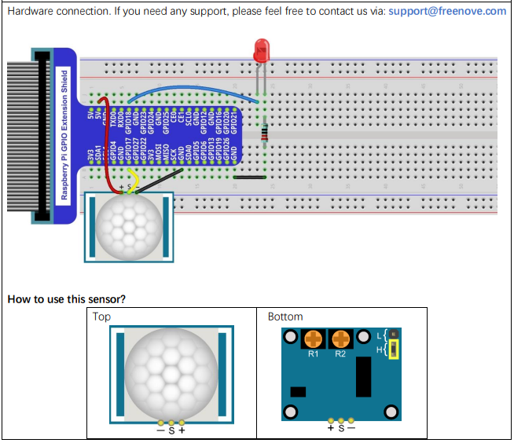

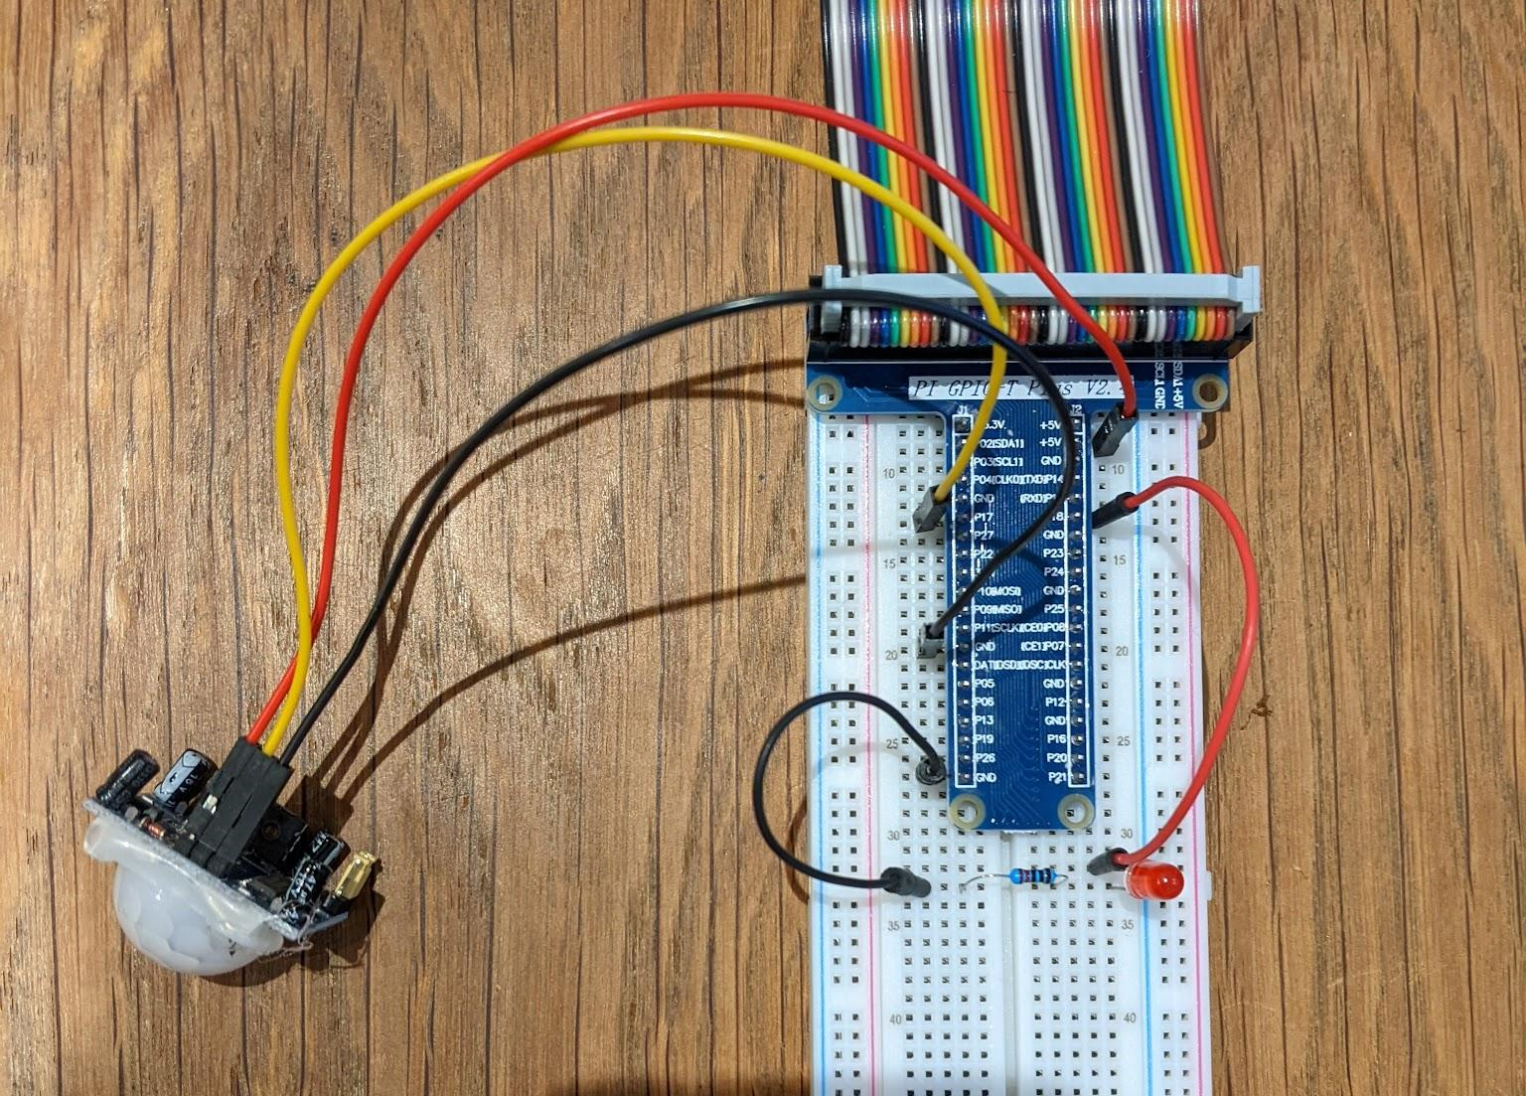

Step 2 - Attach the camera

- Make sure the Pi has been shut down and the power is off. Unplug the power.
- Locate the slot for the camera data ribbon. There are 2 that look similar, about 2 cm long by 2 mm wide and 5 mm high. The one you need is the one in between the HDMI port and the headphone jack.
- The plastic at the top of the slot is used to clamp the ribbon. You need to pull this plastic up to be able to insert the ribbon.
- Insert the ribbon, the blue side of the ribbon should face towards the USB ports and the ethernet port and away from the power port.
- Sometimes the clamp on the ports closes as you insert the ribbon, you have to keep pulling it up while inserting the ribbon. About 4 or 5 mm of blue should still be showing once the ribbon is fully seated.
- Once the ribbon is fully seated, you need to close the clamp. This is fiddly and you may need to hands (I use finger nails) to press on each side of the plastic clamp until it is full down. May require a bit of persistence.
- Power up the Pi.

Step 2 - Enable the camera.

- Open the Pi using VNC.
- Click on the Rapberry in the top left of the window
- Click on Preferences.
- Click on Raspberry Pi Configuration
- Click on the interfaces tab.
- Click the enable toggle for the camera. Check that VNC and SSH are enabled.
- CLick OK.
- Click save.
- Click yes to reboot now.

Step 4 - install RaspController

- Find RaspController on you app store. I use android. I assume there is one for Apple if you have an Apple phone. The icon is a raspberry on a blue background.
- Run RaspCOntroller
- Click the + button to add a device.
- Input the following:
- Device name = MentorPi
- Username = pi
- Host / IP Address = the ip address you use for VNC, you can find this on a Pi by opening a command prompt and typing “ifconfig”. Look for the “192.168.1.XX” number.
- Password = hatpentree
- Press “connection test”.
- It should connect, if not check that all of the above is correct.
- It should say “Connection OK”.
- You should then see a blue save icon towards the bottom right.
- Click the save icon.
- You should now see a list of devices.
- Click “MentorPi”.
- Test by clicking Raspberry Pi Info. This will give you lots of information, even the temperature of the processors. Click back to go back to the previous screen.
- Click on Camera (Legacy) and you should see a stream from the camera.
- Click back to go back to the previous screen. Make sure you do this to exit the camera viewer or the next step may throw up an error as the camera is in use.
- You can do various other things using RaspController. One of the most useful is being able to shutdown or reboot the Pi.

Step 5 - Test taking an image
- Open the Pi using VNC.
- Open a command terminal, the forth icon from the left in the top left corner, a black square “>_” on it and a blue strip at the top.
- Type in “raspistill -o /home/pi/Desktop/test.jpg”. Note that this is case sensitive so big D on desktop.
- A file should appear on the desktop called test.jpg.
- If you get an error make sure that you are not using the camera elsewhere e.g. in RasiController.
- Click on test.jpg and you should see a picture.

Step 6 - Downloading the source code
- Open a file explorer window. This is the 2 yellow folder icon, in the top left of the screen, third icon in from the left.
- This will open to the directory /home/pi. There should be a directory called “src”. Double click to go into this directory.
- If the directory does not exist. Create it. To do this, click the yellow folder icon that has a red plus, second icon in from the left in the file explorer window. This should create a folder that you can name “src”.
- Navigate to the “Desktop” directory. To do this look at the yellow folders in the left hand pane and scroll up and down until you see “Desktop”. Double click to go to Desktop.
- Create a folder called “Images”. To do this, click the yellow folder icon that has a red plus, second icon in from the left in the file explorer window. This should create a folder that you can name “Images”.

- Leave the File Explorer open and then open a command terminal, the forth icon from the left in the top left corner, a black square “>_” on it and a blue strip at the top.
- Type in “cd src”. The promnpt should say “pi@raspberrypi:~/src $“ which indicates you are in the src directory.
- Type in “git clone https://github.com/Zhorod/makerprojects.git”. This should download the software.
- If you go back to the file explorer window, you should see a folder called “makerprojects”.
- Double click on “makerprojects”.
- Double click on “securitycamera”.
- Right click on “securitycamera.py”.
- Click “Thonny Editor IDE”. Thonny is a programming tool, an Integrated Development Environment (IDE).
- Click the big green play button. Assuming everything has gone OK, you should now have a working security camera application. When the sensor detects that a warm body has entered its field of view it turns on the LED and takes a picture.

Step 7 - Updating the software

- Open a command prompt.
- Type in “cd src”. “cd” means change directory.
- Type in “cd makerprojects”.
- Type in “git pull origin master”.
- This will pull any new software in the makerprojects git repository. You can go to “www.github.com” and search for “Zhorod/makerprojects” which will take you to the home page for the repository, which is public, and you can see the software.

Step 8 - explore

- Try changing the code a bit and see what happens.
- Try adding these line to the code to see what happens. You need to add them just before the “camera.capture” line and make sure the lines are all vertically aligned. Spacing is important in Python.
- Look online for information about the raspberry pi camera and see if you can find some other commands or image effects e.g. rotate the image.
- Don’t forget to delete out the files after a while or you will fill up the Pi. You can do this from file explorer. Press control and a to select all and then press delete on the keyboard.

There is a chance that you have to install libcamera. To do this you need to enter the following commands into a command prompt.

sudo apt install meson
sudo apt install ninja
git clone https://git.libcamera.org/libcamera/libcamera.git
cd libcamera
sudo meson build
sudo ninja -C build install

